Fresh Juices  Green Blast  Kale, spinach, carrot, lime, ginger, apple 7.99  Iron Chick  Beet, ginger, orange, carrot, apple 8.15  Ginger Sun  Apple, grapefruit, ginger 6.99  Refuel  Cucumber, carrot, apple, ginger, lime 6.99  Smoothies  Mighty Leaf  Spinach, kale, banana, blueberry, coconut water 7.25  Blue Chick  Vanilla yogurt, strawberries, blueberries, chia seed, almond milk 6.99  Banana Split  Banana, nutella, vanilla yogurt, milk 7.25  Strawberry Banana  Strawberry, banana, orange juice or almond milk 5.99 |  |  | 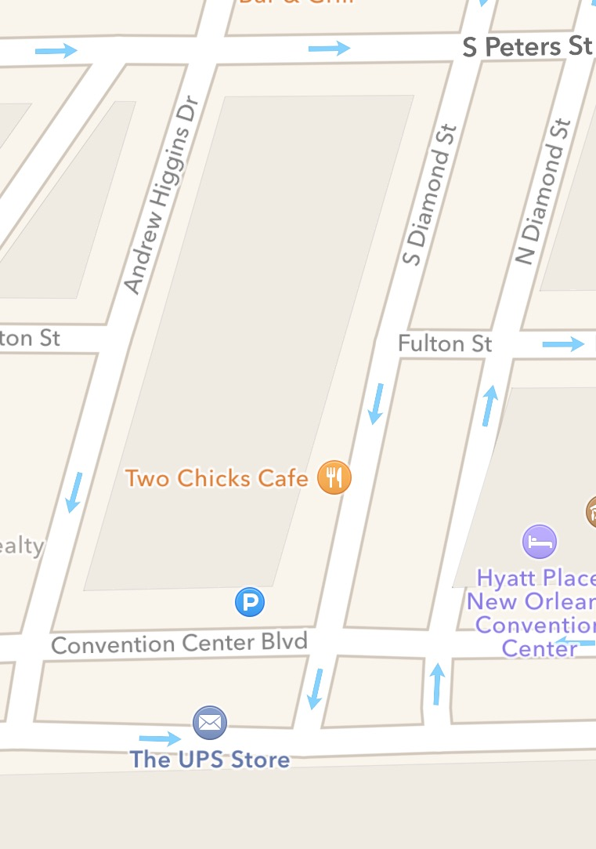  Visit our webpage at Twochickscafe.com & follow us on Facebook. |  |  | Breakfast ·Lunch ·Juice Bar  (504)407.3078  Open Tuesday - Sunday  7:00am – 3:00pm  901 Convention Center Blvd  Suite 109  New Orleans, LA 70130

Breakfast (Served all day)  All omelets and benedicts come with choice of creamy grits, roasted potatoes or fruit. Toast is included with omelets.  Kickin’ Chicken Omelet  Chicken breast, red onion, mushroom, spinach, and goat cheese topped with homemade salsa 10.99  Farmhouse Omelet  Turkey, smoked gouda, diced tomato, and green onion 10.25  Under the Sea Omelet  Crab meat, shrimp, brie, bell pepper, green onion, garnished with dill 11.99  Build your Chicks Omelet 5.50  Meat: Andouille sausage, bacon, ham, turkey, chicken - add 1.75ea  Seafood: shrimp, crabmeat - add 1.99ea  Cheese: smoked gouda, gruyere, brie, goat cheese - add 1.25ea  Veggie: mushroom, red onion, green onion, spinach, bell pepper, tomato, jalapeno - add 0.50ea  *Egg whites upcharge 1.00  Traditional Benedict  Poached eggs, hickory-smoked ham, Cajun Hollandaise on a croissant 10.75  Crab Cake Benedict  Poached eggs, crab cake, Cajun hollandaise on a croissant 13.50  Veggies Benedict  Poached eggs with sautéed mushroom, onion, bell pepper, tomato, and spinach topped with Cajun hollandaise on a croissant 10.25  *Cajun hollandaise contains creole mustard and hot sauce  Café Breakfast  Two eggs your way, with a choice of meat, choice of roasted potatoes, fruit or creamy grits, and toast 8.50 |  |  | Eggwich  Hatchery: fried egg, spinach, tomato, mushrooms, goat cheese on croissant 6.25  Belt: bacon, fried egg, kale, tomato, mayo on corn dusted jalapeno toast 6.99  Barnyard: smoked turkey, fried egg, basil, herbed cream cheese spread on marble rye 6.99  Buttermilk Pancakes  Homemade pancakes topped with fresh fruit 8.50  Papa’s French Toast  Two thick slices of Texas toast dipped in vanilla rum batter. Rolled in corn flakes & topped with fresh fruit 8.75  Buckwheat Savory Crepe GF  Turkey Crepe: Egg, goat cheese, turkey, spinach, tomato, green onion 8.50  Seafood Crepe: Egg, crab meat, shrimp, brie, green onion, bell pepper, spinach, garnished with dill 9.50  Vegetarian Crepe: Egg, sautéed mushroom, onion, bell pepper, tomato, spinach, and goat cheese 8.50  Sweet Crepes  • Nutella and banana 7.99  • Strawberry and cream 7.99  Parfait  Yogurt, granola, fresh fruit 6.25  Chia Pudding GF  Homemade vanilla chia pudding topped with bananas, blueberries and nuts 6.25  BBQ Shrimp and Grits  Spicy dark roux over creamy grits with sliced baguettes 14.50  A La Carte  Creamy grits 2.99  Roasted potatoes 2.99  Fruit cup 2.99  Two eggs 2.50  Andouille sausage, bacon, ham, turkey 3.25  Multigrain/ Texas toast/ Rye 1.99  One pancake 2.25 |  |  | Lunch (Starts at 11:00am)  All sandwiches come with side salad  Grown Up Grilled Cheese  Layered slices of gruyere, smoked gouda,  pickled beet and Creole mustard on corn dusted jalapeno toast 10.25 –Add hickory smoked ham  or bacon 1.75  Turkey Fig  Turkey, goat cheese, tomato and fig spread on marble rye 10.99  Thai Shrimp Poboy  Grilled shrimp, sweet chili sriracha coleslaw, mayo on French bread 12.75  Veggie Sandwich  Sautéed mushroom, onion, bell pepper, tomato, spinach, with goat cheese on marble rye 9.99  Crab Melt  Brie, homemade crab meat mix on Texas Toast 15.75  Cajun Sandwich  Andouille sausage, smoked gouda, Creole mustard, sliced pickles on ciabatta 10.50  Chicken Panini  Grilled chicken breast, gruyere, fresh spinach, tomato with pesto on ciabatta 11.25  Chicken Club Sandwich  Grilled chicken breast, crispy bacon, smoked gouda, tomato, kale and spicy mayo on corn dusted jalapeno toast 12.99  Quinoa Salad GF  Quinoa, carrot, tomato, kale, mixed greens, Tuscany vinaigrette 7.25  Add chicken 4.50 or shrimp 4.99  Mixed Greens GF  Mixed greens, tomato, boiled egg, chopped bacon, gruyere, chianti basil vinaigrette 7.75  Add chicken 4.50 or shrimp 4.99

